Handwritten Digit Classification with KNN and Neural Networks
Allen Gao
University of Massachusetts Amherst
MIE622
Michael Prokle
A writing test was used by a school to understand which young students may need additional support developing their motor skills. Students were asked to write numbers, and the resulting pixel information was used to determine whether a machine-learning model could correctly identify each number. A K-nearest neighbors model was developed as a simple starting approach and compared with a more complex neural network. The two models were evaluated based on prediction accuracy, consistency between training and testing performance, and computation time. Although successful number recognition could help the school identify writing samples that may require further review, the models should be treated as preliminary screening tools rather than substitutes for assessments by teachers or qualified specialists.
Data Cleansing and Setting up
After the dataset was loaded from the CSV file, it was examined for duplicate observations, missing values, and question-mark placeholders indicating unknown information. No missing values or question-mark placeholders were identified. However, 1,633 exact duplicate observations were found and removed before the models were developed. The duplicate observations were removed to prevent repeated records from being overrepresented and reduce the possibility that identical observations would appear in training and test datasets, which could make them appear more accurate than they would be on new writing samples and prevent them from overfitting the model when classifying unseen data. The target variable, which represented the number shown in each writing sample, was separated from the pixel intensity predictors. The predictors and the target were then divided into 70% training and 30% test datasets. StandardScaler was then used to fit and transform the training predictors, while the fitted scaler was used only to transform the testing predictors. This placed the pixel predictors on a consistent scale, which supported the KNN distance calculations and helped the neural network train more reliably.
K-Nearest Neighbor Analysis
The K-Nearest Neighbor(KNN) classifier was the first model used to examine how accurately a relatively simple machine-learning algorithm could identify handwritten numbers from their pixel intensity. The first step was to create a list of candidate K values for GridSearchCV to evaluate with the KNN classifier. GridSearchCV was then fitted using only the training data and evaluated each candidate through three-fold cross-validation. For every value of K, the model was trained three times so that each fold served as the validation set once. The three validation accuracies were averaged, and the K value with the highest average accuracy was selected for the final model. The k value that had the highest average cross-validation accuracy was printed out, showing that the best k value to use for the KNN was 15, where it had the highest accuracy among the rest of other candidate k values, which was 64.84%.
After the optimal K value was identified, the KNN estimator with the highest average cross-validation accuracy was used to predict the number labels for the observations in the testing dataset. The predicted labels were then compared with the actual labels to calculate the model’s final testing accuracy, which was 65.54%, which could mean that it was that KNN model was able to correctly identify about two out of every three handwritten numbers. Although the model performed better than random guessing, its accuracy was not particularly strong because it still misclassified 34.46% of the testing observations. To show the results, the first 15 testing observations were displayed with their predicted and actual number labels. Each observation also indicated whether the predicted label matched the actual label, providing examples of both correct and incorrect classifications.
One challenge encountered when using the KNN model was the time required for GridSearchCV to identify the optimal value of K. KNN stores the training observations and calculates distances between each new observation and many of the stored observations when making predictions. GridSearchCV repeated these calculations for every candidate K value across three validation folds, which substantially increased the computation time. Therefore, the number of candidate K values had to be limited to keep the analysis manageable. Another challenge was the variation in how different students could write the same number. Writing samples representing the same digit may contain different pixel patterns, while different digits may sometimes produce similar patterns. Because KNN bases its predictions entirely on the distances between these pixel values, this variation could cause the nearest observations to contain incorrect labels and may have contributed to the model’s limited testing accuracy. The KNN produced mixed results but correctly classified the majority of the handwritten numbers, with a testing accuracy of 65.54%. Although the model made too many errors to classify handwritten numbers reliably on its own, it could still help the school flag difficult-to-recognize writing samples from students who may need further support. However, these results would need to be reviewed by teachers or qualified specialists because an incorrect prediction does not necessarily indicate that a student has difficulty with motor skills.
Neural Network Analysis
Before the final neural-network model was selected, a list was created containing the four activation functions supported by the multi-layer Perceptron classifier (MLPClassifier): identity, logistic sigmoid function, hyperbolic tangent function (tanh), and rectified linear unit (ReLU) function. The model used a hidden layer that contains 60 neurons, the stochastic gradient descent solver, an initial learning rate of 0.05, a maximum of 15,000 iterations, and a random state of 42. The list was then used in a loop that created and trained a separate neural-network model with each activation function. The model settings were kept the same so that differences in training and testing accuracy could be compared more fairly. An empty list was initialized to store the name of the activation function and the training and testing accuracies for each MLPClassifier model, where the random state helped ensure the results were reproducible. Comparing these accuracies helped evaluate each model’s fit, as a smaller difference indicated more consistent performance, while a larger difference suggested possible overfitting.
Once the loop had evaluated all four activation functions, the list containing their training and testing accuracies was converted into a DataFrame. The table was then sorted from highest to lowest testing accuracy, making it easier to identify the best-performing activation function and compare each model’s training and testing performance, as shown in Figure A1. Among the activation functions, ReLU achieved the highest testing accuracy of 69.46% and maintained a reasonably consistent relationship between its training and testing results. Similar to KNN, it achieved relatively the same accuracy but slightly higher than that of KNN, which indicates that the more complex model provided a modest improvement in identifying the handwritten numbers. One of the reasons why it may have a moderate accuracy is that the dataset contains just 45 pixel-intensity predictors, which may not have captured every important part of each handwritten number. Different digits could therefore have similar recorded pixel patterns, while the same digit could appear differently because of variations in individual handwriting styles. This limitation could have made it more difficult for the neural network to learn patterns that consistently distinguished all 10 numbers.
One of the challenges that was faced when using the neural network was trying to find the right model settings. Changes to the number of hidden neurons, activation function, learning rate, and maximum number of iterations affected the model’s accuracy, fit, and computation time, so several configurations had to be tested before selecting a reasonable final model to be used to be benchmarked against KNN. If some model settings were set too high or too low, the neural network could learn inefficiently or become unstable, which negatively affected the model’s performance. Another challenge that I faced using MLPClassifier was the amount of computation time required to test multiple activation functions. A separate neural network had to be trained with the training dataset for each activation function, and each model required many iterations before reaching a stable result. Repeating this process for several model configurations made the neural-network analysis time-consuming. The additional computation time was difficult to avoid because each activation function processes information differently and therefore required a separately trained model. Evaluating each function under the same conditions was necessary to determine which one provided the strongest testing performance.
All in all, the ReLU neural network provided the strongest testing performance among the activation functions and modestly improved upon the KNN model. However, its moderate accuracy, longer computation time, and sensitivity to model settings limited its practical reliability. The neural network could help flag the difficult-to-recognize writing samples better, but the result would still require review by teachers or qualified specialists.
Model Benchmarking and Recommendation
To benchmark the two models, the final KNN and ReLU neural-network classifiers were placed in a dictionary, where each model name served as a key, and its classifier served as the corresponding value. The configurations that the final model had helped each of their respective models achieve the highest possible test accuracy. A loop then fitted each model using the same scaled training data and evaluated it with the same scaled testing data. For each model, the training accuracy, testing accuracy, absolute difference between those accuracies to see the model’s fit, and the computation time were calculated and stored in a results list. The results list was then converted into a DataFrame so that the two models could be compared in a single table, which is printed out as shown in Figure A2.
As shown in the figure, the school should select the ReLU neural network over the KNN model because it achieved higher training and testing accuracies. Most importantly, its higher testing accuracy indicates that it classified previously unseen writing samples more successfully than KNN. Also, it seems that the neural network demonstrated a slightly more consistent fit because it had the smaller gap between its training and testing accuracies. The accuracy gap for the neural network is approximately .003 less than the KNN model’s gap. Although this difference was small, it indicated that the neural network maintained slightly more consistent performance between the two datasets and showed marginally less evidence of overfitting. While the neural network achieved better accuracy and a slightly more consistent fit, the KNN model was considerably faster and required much less computation time of .52 seconds.
All in all, the school should pick the neural network because it achieved the stronger testing accuracy and a slightly more consistent model fit. Although it required more computation time than KNN, correctly identifying the handwritten numbers was the school’s primary objective.
Conclusion
Both neural network and KNN models did moderately well when classifying the handwritten numbers. KNN provided a simpler and faster baseline, achieving a testing accuracy of 64.71%, while the MLPClassifier neural network using ReLU achieved a higher testing accuracy of 68.46% and a slightly more consistent fit but required more computation time during the benchmark. The ReLU neural network is the preferred model when accuracy is usually prioritized over speed. Although neither model was accurate enough to identify the handwritten numbers reliably in every case, the results could help the school flag writing samples for closer review and support efforts to identify young students who may need additional assistance developing their motor skills. The neural network should only be used as a decision-support tool to flag writing samples for further review. The teachers or qualified specialists from the schools should remain responsible for determining whether a student needs additional assistance with motor skills.
Appendix
Figure A1
Training and Testing Accuracy by Neural-Network Activation Function
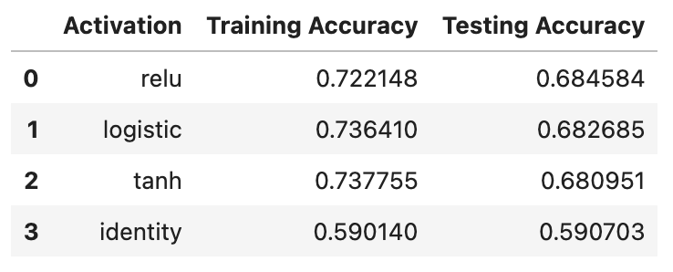
Figure A2
Benchmark Comparison of KNN and the ReLU MLPClassifier Neural Network

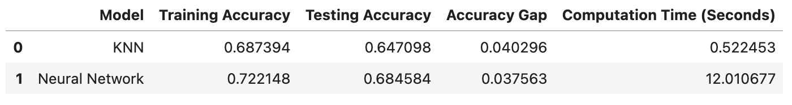
Note: Accuracy gap represents the absolute difference between training and testing accuracy, with smaller values indicating a more consistent fit. Computation time includes fitting the final model and scoring the testing dataset.

